**A cura di Padre Secondo Brunelli crs**

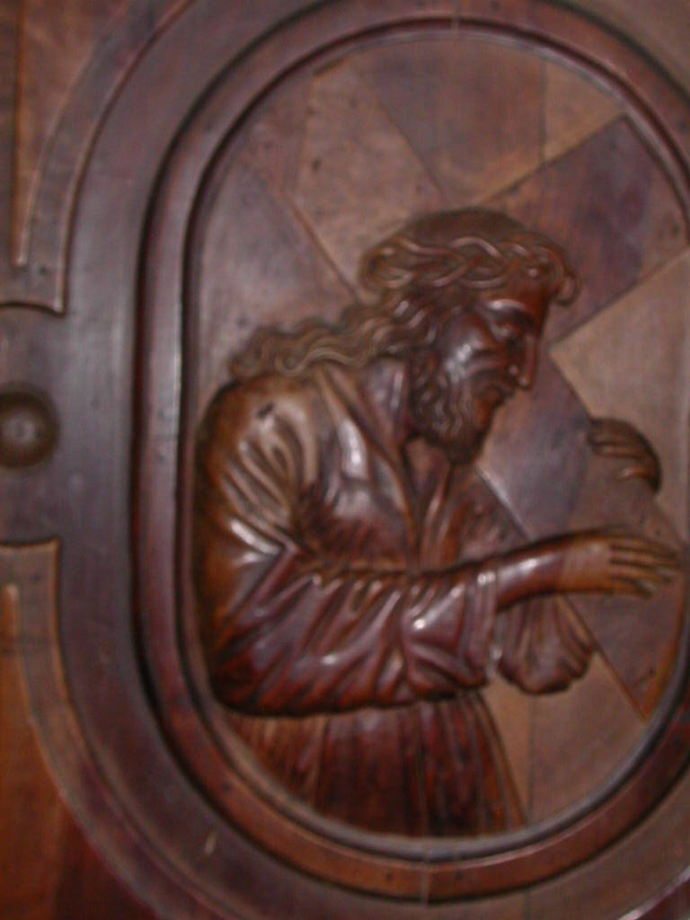

Gesù portracroce, Chiesa dei SS. Vittore e Corona, Feltre

**BELLUNO**

**RELIGIOSI SOMASCHI**

**1696-1786**

**Mestre 24.4.2019**

**P. Marco Tentorio, Il Seminario di Belluno i PP. Somaschi, pag. 1-38, fascicolo dattiloscritto, mai pubblicato.**

**1649**

|  |  |  |  |
| --- | --- | --- | --- |
| *P. Malloni Giovanni* | *Vescono, 70 anni* | *7.2.1649* | ***+ 7.2.1649*** |

*(1) Riv. Congr., fasc. 8, 1926, P. Malloni Giovanni, pag. 42-43*

**1694**

|  |  |  |  |
| --- | --- | --- | --- |
| *P. Cupilli Stefano* | *Direttore* | *Ago 1664*  *8.9.1694* | *Da S. Nicolò FE* |

**1695**

|  |  |  |  |
| --- | --- | --- | --- |
| *P. Cupilli Stefano* | *Direttore* | *1695* |  |

**1696**

|  |  |  |  |
| --- | --- | --- | --- |
| *P. Cupilli Stefano* | *Direttore* | *1696* |  |

**1697**

|  |  |  |  |
| --- | --- | --- | --- |
| *P. Caporino Pietro* |  | *1697* | *( Da Salute VE )* |
| *P. Cupilli Stefano* | *Direttore* | *1697* |  |

**1698**

|  |  |  |  |
| --- | --- | --- | --- |
| *P. Caporino Pietro* |  | *Presente* |  |
| *P. Cupilli Stefano* | *Direttore* | *1698* |  |
| *P. Manara Michelangelo* | *Rettore* | *1698* | *Da Sem. Patr. VE* |

**1699**

|  |  |  |  |
| --- | --- | --- | --- |
| *P. Caporino Pietro* | *Maestro* | *1699* |  |
| *P. Manara Michelangelo* | *Rettore* | *1699* |  |
| *P. Sorio Zaccaria* | *Maestro* | *1699* | *Da Salute VE* |
| *P. Valle* | *Assistente* | *1699* |  |
| *Fr. Xamini Giovanni* |  | *1699* |  |

**1700**

|  |  |  |  |
| --- | --- | --- | --- |
| *P. Caporino Pietro* |  | *1700* |  |

**1701**

|  |  |  |  |
| --- | --- | --- | --- |
| *P. Caporino Pietro (1)* |  | *Mar. 1701* | ***+ Mar. 1701*** |
| *P. Frugoni Innocenzo Carlo* |  | *1701* | *Arrivo* |
| *P. Manara Michelangelo* | *Rettore* | *1701* |  |
| *P. Petricelli G.Domenico* | *Rettore* | *1701* |  |

*(1) Riv. Congr., fasc. 38, 1931, P. Caporino Pietro, pag. 112*

**1702**

|  |  |  |  |  |
| --- | --- | --- | --- | --- |
| *P. Frugoni Carlo*  *Atti Verona* | | *Fuggitivo da BL* | *22.4.1702* | *A Verona* |
| *P. Petricelli G.Domenico* | *Rettore* | *1702* | *Da Mendicanti VE* |

**1703**

|  |  |  |  |
| --- | --- | --- | --- |
| *P. Petricelli G.Domenico* | *Rettore* | *1703* | *Alla Salute VE* |

**1704**

**1705**

**1706**

**1707**

**1708**

|  |  |  |  |
| --- | --- | --- | --- |
| *P. Manara Michelangelo* | *Rettore* | *1708* |  |

**1709**

|  |  |  |  |
| --- | --- | --- | --- |
| *P. Pacata Taddeo* | *Rettore* | *1709* |  |

**1710**

|  |  |  |  |
| --- | --- | --- | --- |
| *P. Pacata Taddeo*  *Atti Salute VE* | *Rettore a Belluno* | *6.12.1710* |  |

**1711**

|  |  |  |  |
| --- | --- | --- | --- |
| *P. Pacata Taddeo*  *Atti Salute VE* | *Prep.to a Belluno* | *18.9.1711* |  |

**1712**

|  |  |  |  |  |  |  |  |
| --- | --- | --- | --- | --- | --- | --- | --- |
| *P. Manara Michelangelo* | | | *Rettore* | *Gen. 1712* | |  | |
| *P. Pacata Taddeo*  *Atti Salute VE* | *Rettore a Belluno* | | | *3.3.1712*  *19.5.1712* | |  | |

**1713**

|  |  |  |  |
| --- | --- | --- | --- |
| *P. Manara Michelangelo* | *Rettore* | *Gen. 1713* |  |
| *P. Pacata Taddeo* | *Rettore* | *Gen. 1713* | *A Salute VE* |

**1714**

|  |  |  |  |
| --- | --- | --- | --- |
| *P. Manara Michelangelo* | *Rettore* | *1714* |  |

**1715**

|  |  |  |  |
| --- | --- | --- | --- |
| *P. Manara Michelangelo* | *Rettore* | *1715* | *All’Ospitaletto VE* |

**1716**

|  |  |  |  |
| --- | --- | --- | --- |
| *P. Fontana Francesco* | *Rettore* | *1716* |  |

**1717**

|  |  |  |  |
| --- | --- | --- | --- |
| *P. Fontana Francesco* | *Rettore* | *1717* | *A Verona* |
| *P. Sorio Zaccaria* | *Rettore* | *1717* |  |

**1718**

|  |  |  |  |  |  |
| --- | --- | --- | --- | --- | --- |
| *P. Bertucci Zaccaria* | *Rettorica* | *1718* | |  | |
| *P. Sorio Zaccaria* | *Rettore* | | *1718* | |  |

**1719**

|  |  |  |  |
| --- | --- | --- | --- |
| *P. Bertucci Zaccaria* | *Rettorica* | *1719* |  |
| *P. Farei Francesco* |  | *1719* |  |
| *P. Sorio Zaccaria* | *Rettore* | *1719* |  |
| *Fratello* |  |  |  |
| *Fratello* |  |  |  |

**1720**

|  |  |  |  |
| --- | --- | --- | --- |
| *Mons. Bembo* | *Vescovo bi Belluno* | *21.7.1720* | *+ 21.7.1720* |
| *P. Bertucci Zaccaria* | *Rettorica* | *21.7.1720* |  |
| *P. Sorio Zaccaria* | *Rettore* | *1720* |  |

**1721**

|  |  |  |  |  |  |  |
| --- | --- | --- | --- | --- | --- | --- |
| *P. Amort Gaetano* |  | | | *1721* | | *Da Cividale* |
| *P. Bertucci Zaccaria* | *Rettorica* | | | *1721* | |  |
| *P. Sorio Zaccaria* | | *Rettore* | *1721* | |  | |

**1722**

|  |  |  |  |  |  |
| --- | --- | --- | --- | --- | --- |
| *P. Ambrosi Francesco* | | | *Rettore* | *1722* | *Da Feltre* |
| *P. Amort Gaetano* | | |  | *1722* | *Arrivo* |
| *Fr. Baldini Girolamo*  *Atti Salute VE* | *In Belluno* | | *30.9.1722* | *+ 30.9.1722* | |
|  |  | |  |  | |
| *P. Bertucci Zaccaria* | *Rettorica* | | *1722* |  | |

**1723**

|  |  |  |  |  |  |  |  |  |  |  |
| --- | --- | --- | --- | --- | --- | --- | --- | --- | --- | --- |
| *P. Ambrosi Francesco* | | *Rettore* | | | *1723* | | |  | | |
| *P. Amort Gaetano* | | |  | | | *1723* | | |  | | |
| *P. Bertucci Zaccaria* | | | *Rettorica* | | | *1723* | | |  |

**1724**

|  |  |  |  |  |  |  |  |  |  |
| --- | --- | --- | --- | --- | --- | --- | --- | --- | --- |
| *P. Ambrosi Francesco* | | *Rettore* | | *1724* | | |  | | |
| *P. Amort Gaetano* | | |  | | *1724* | | |  | | |
| *P. Bertucci Filippo*  *Atti Salute VE* | | *Era a Belluno* | | | *28.9.1724* | | | *A S. Giustina Salò* | |

**1725**

|  |  |  |  |  |  |  |  |
| --- | --- | --- | --- | --- | --- | --- | --- |
| *P. Ambrosi Francesco* | | *Rettore* | | *1725* | |  | |
| *P. Amort Gaetano*  *Atti Feltre* | |  | | *10.6.1725* | | *A Feltre* |
| *P. Orsezio Felice* | | *Maestro* | | *1725* | |  |
| *Ch. Orsezio Scipione*  *Atti Salute VE* | |  | | *7.2.1725* | | *Alla Salute VE* |

**1726**

|  |  |  |  |  |  |  |  |  |
| --- | --- | --- | --- | --- | --- | --- | --- | --- |
| *Ch. Miari Emiliano.* | | *Noviziato* | | | *1726* | |  | |
| *P. Moiolo G. Battista* | | *Rettore* | *1725* | |  | |

**1727**

|  |  |  |  |  |  |  |  |  |  |
| --- | --- | --- | --- | --- | --- | --- | --- | --- | --- |
| *P. Ambrosi Francesco* | | | *Maestro* | | *1727* | |  | | |
| *Ch. Franzoni Antonio*  *Atti Salute VE* | |  | | *14.11.1727*  *15.11.1727* | | | *Alla Salute VE* |
| *P. Laiolo G. Battista*  *Atti Feltre* | | *Vestizione* | | *8.7.1727*  *5.11.1727* | | | *Sem. Belluno* |
| *Ch. Miari Emiliano*  *Riv. Congr.* | | *Professione* | | *5.11.1727* | | |  |
| *P. Moiolo G.Battista*  *Atti Salute VE* | | | *Prep.to Belluno* | | *11.6.1727*  *5.11.1727*  *15.11.1727* | |  | | |

**1728**

|  |  |  |  |  |  |  |  |
| --- | --- | --- | --- | --- | --- | --- | --- |
| *P. Ambrosi Francesco* | | *Maestro* | | *1728* | |  | |
| *Ch. Miari Emiliano* | |  | | *1728* | | *A Clementino RM* |
| *P. Moiolo G.Battista*  *Atti Feltre* | | *Rettore* | | *13.7.1728* | | *Da Feltre* |

**1729**

|  |  |  |  |  |  |  |
| --- | --- | --- | --- | --- | --- | --- |
| *P. Ambrosi Francesco* | | *Maestro* | | *1729* | |  |
| *P. Moiolo G.Battista* | | *Rettore* | | *1729* |  |

**1730**

|  |  |  |  |
| --- | --- | --- | --- |
| *P. Ambrosi Francesco* |  | *24.12.1730* | ***+ 24.12.1730*** |
| *P. Moiolo G.Battista* | *Rettore* | *1730* |  |

**1731**

|  |  |  |  |  |  |  |
| --- | --- | --- | --- | --- | --- | --- |
| *P. Ambrosi Francesco*  *Atti Salute VE* | *In Belluno* | | *6.1.1731* | | *+ 6.1.1731* | |
| *P. Moiolo G.Battista*  *Atti Salute Ve* | | | *Rettore*  *Morto in VE* | | *1731*  *7.9.1731* | ***+ 7.9.1731*** |
| *P. Sorio Zaccaria* | | | *Rettore* | | *1731* |  |

**1732**

|  |  |  |  |
| --- | --- | --- | --- |
| *P. Sorio Zaccaria* | *Rettore* | *17321* | *A Feltre* |

**Nel 1769 avviene la forzata separazione della Provincia Veneta dal corpo della Congregazione.**

**1786**

|  |  |  |  |
| --- | --- | --- | --- |
| *Mons. Alcaini Sebastiano*  *Atti Salute VE* | *Vescovo* | *17.3.1786* | *A Belluno* |