**A cura di padre Secondo Brunelli crs**

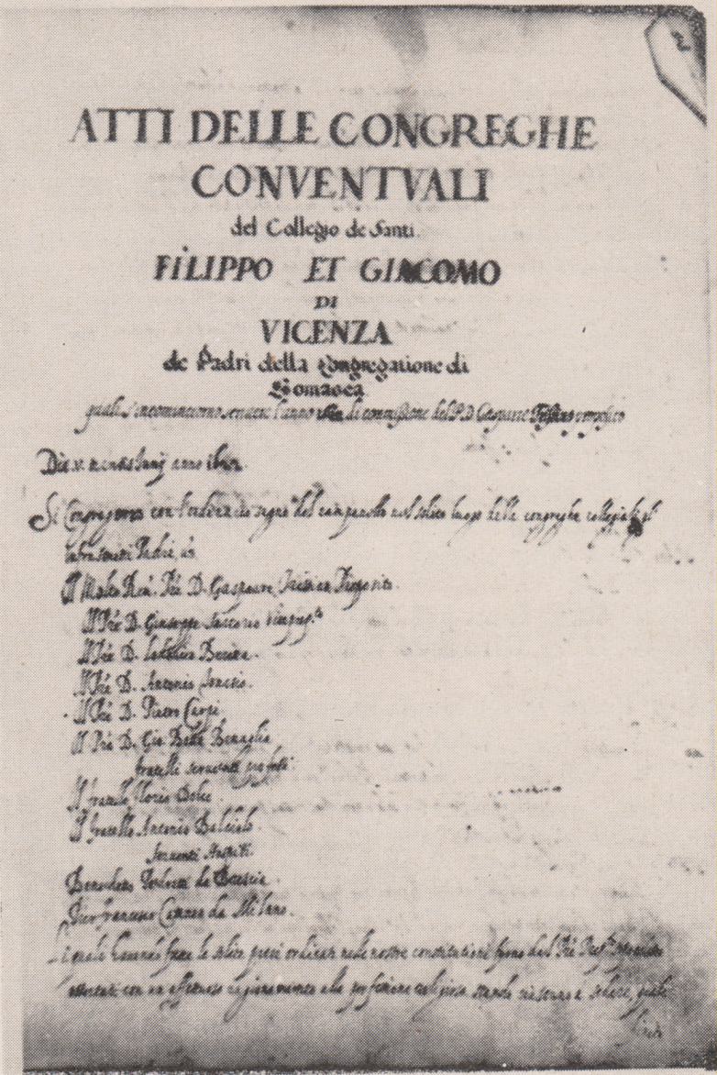

**RELIGIOSI SOMASCHI**

**AI SANTI FILIPPO E GIACOMO**

**1583-1700**

**Mestre 29.4.2017**

**1583**

|  |  |  |  |
| --- | --- | --- | --- |
| P. Cimarelli Alessandro |  | 1583  10.8.1583 | Da Genova |

**1584**

**1585**

**1586**

**1587**

|  |  |  |  |
| --- | --- | --- | --- |
| P. Fornasari G. Battista | Preposito | 26.8.1587 |  |

**1588**

**1589**

**1590**

**1591**

**1592**

**1593**

**1594**

**1595**

**1596**

**1597**

**1597**

**1598**

**1599**

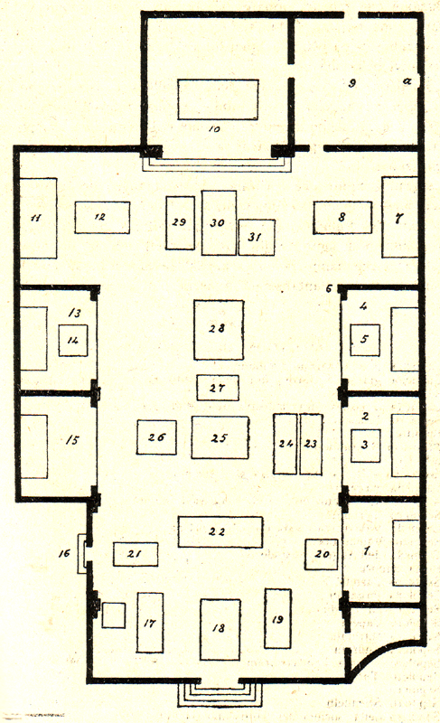

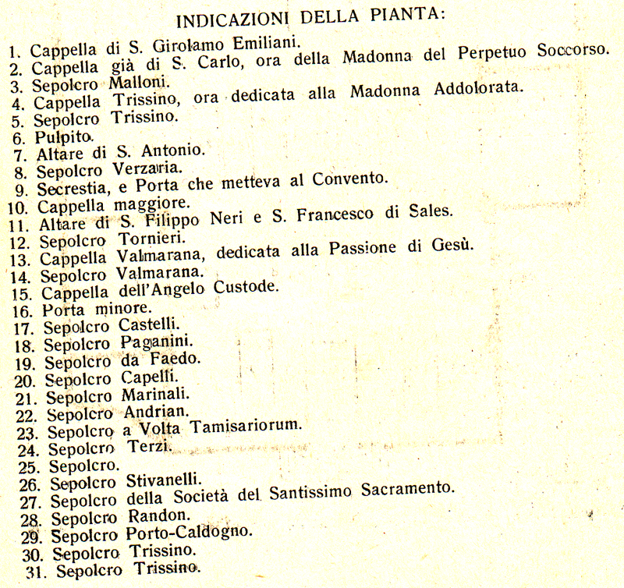

**1600**

|  |  |  |  |
| --- | --- | --- | --- |
| P. Porto ??? |  | 7.1.1600 |  |
| P. Stella Andrea | Preposito  Procuratore | 1600  27.10.1600 |  |
| *** |  |  |  |
| P. Terzano Andrea | Generale | 27.10.1600 |  |

**1601**

|  |  |  |  |  |
| --- | --- | --- | --- | --- |
| P. Antonio |  | 1.6.1601 | |  |
| P. Cremaschi Andrea |  | 1.6.1601 | |  |
| Fr. Intriviso Natale |  | 1.6.1601 | |  |
| Fr. Solino Marcantonio |  | | 1.6.1601 |  |
| P. Stella Andrea | Preposito | | 1.6.1601 |  |
| P Tagliapietra Alvise |  | | 10.1.1601  10.7.1601 |  |
| *** |  | |  |  |
| P. Assareto G. Battista | Generale | | 10.5.1601 |  |
| P. Tinti Girolamo | Rettore Misercor. | | 2.6.1601 |  |

**1602**

|  |  |  |  |
| --- | --- | --- | --- |
| P. Stella Andrea | Preposito | 24.6.1602  16.12.1602 | In Dalmazia |
| P. Tagliapietra Alvise |  | 11.1.1602 |  |

**1603**

|  |  |  |  |
| --- | --- | --- | --- |
| *** |  |  |  |
| P. Ganna Biagio | In Venezia | 15.1.1603 |  |

**1604**

**1605**

|  |  |  |  |
| --- | --- | --- | --- |
| P. Anguisciola Alvise | Preposito | 1605 |  |

**1606**

**1607**

**1608**

|  |  |  |  |
| --- | --- | --- | --- |
| P. Stella Andrea | Preposito | 14.1.1608 |  |
| *** |  |  |  |
| P. Fabbreschi G. Battista | Proc. Generale | 9.6.1608 |  |
| P. Ganna Biagio | Rettore Semin. VI | 14.1.1608 |  |

**1609**

**1610**

**1611**

**1612**

**1613**

**1614**

|  |  |  |  |
| --- | --- | --- | --- |
| P. Cornalba Desiderio | Preposito | 12.5.1614 |  |
| *** |  |  |  |
| P. Corsoio Evangelista | Rettore Salute VE | 12.5.1614 |  |

**1615**

**1616**

**1617**

**1618**

**1619**

**1620**

**1621**

**1622**

**1623**

**1624**

**1625**

**1626**

**1627**

**1628**

**1629**

**1630**

**1631**

**1632**

**1633**

**1634**

**1635**

**1636**

**1637**

**1638**

**1639**

**1640**

**1641**

|  |  |  |  |
| --- | --- | --- | --- |
| P. Marchi Marcantonio |  | 1641 |  |
| P. Sartorio Giuseppe |  | 1641 |  |
| *** |  |  |  |
| P. Carrara Paolo | Vicario Generale | 1641 |  |
| P. Priuli G. Francesco |  | 1641 |  |
| P. Varese Ambrogio | Generale | 1641 |  |

**1642**

|  |  |  |  |  |  |  |
| --- | --- | --- | --- | --- | --- | --- |
| P. Marchi Marcantonio | |  | | 17.2.1642 |  | |
| *** |  | |  | | |  |
| P. Carrara Paolo | Vicario Generale | | 1642 | | |  |
| P. Moro Pietro | Rett.Mendicanti VE | | 1642 | | |  |
| P. Priuli G. Francesco |  | | 1642 | | |  |

**1643**

**1644**

**1645**

**1646**

**1647**

**1648**

**1649**

|  |  |  |  |
| --- | --- | --- | --- |
| P. Benaglia G. Battista | Curato | 17.10.1649 |  |

**1650**

**1651**

**1652**

|  |  |  |  |
| --- | --- | --- | --- |
| P. Cerchiari Bartolomeo | Vicepreposito | 7.3.1652 |  |
| P. Priuli Girolamo | Preposito | 7.3.1652 |  |
| P. Ricco Giuseppe Senior |  | 7.3.1652 |  |
| P. Rutta G. Francesco | Commissario (?) | 7.3.1652 |  |

**1653**

**1654**

**1655**

**1656**

**1657**

**1658**

**1559**

**1660**

**1661**

**1662**

|  |  |  |  |
| --- | --- | --- | --- |
| *** |  |  |  |
| P. Marchi Marcantonio | Rett. Miseric. VI | 28.6.1662 |  |

**1663**

|  |  |  |  |
| --- | --- | --- | --- |
| P. Cerchari Bartolomeo |  | 2.10.1663  2.12.1663 |  |
| P. Marchi Marcantonio | *Da Misericordia VI* | 5.10.1663 | *Da Misericordia VI* |
| *** |  |  |  |
| P. Ferrigelli David |  | 5.10.166 |  |
| P. Ronzoni | Provinciale | 5.10.166 |  |

**1664**

|  |  |  |  |
| --- | --- | --- | --- |
| P. Fumarelli Antonio | Attuario | 16.10.1664 |  |
| P. Marchi Marcantonio | Preposito | 29.3.1664  19.4.1664  23.4.1664  28.5.1664  2.6.1664  10.6.1664  16.7.1664  14.8.1664  27.8.1664  4.9.1664  29.9.1664  19.10.1664  21.10.1664  2.11.1664  10.11.1664  19.11.1664  2.12.1664 |  |
| P. Priuli Girolamo | Rettore | 16.10.1664 |  |
| *** |  |  |  |
| P. Buffa | Rettore | 29.9.1664  19.10.1664  2.11.1664 |  |
| P. Danieli | Preposito | 16.7.1664  19.11.1664 |  |
| P. Ferrari | Rettore | 4.9.1664  10.11.1664 |  |
| P. Fanzago | Rettore | 10.6.1664  14.8.1664 |  |
| P. Ferrari | Rettore | 4.9.1664  10.11.1664 |  |
| P. Ferrigelli David |  | 23.4.1664  14.8.1664  21.10.1664 |  |
| P. Passi | Consigliere | 16.7.1664  19.11.1664 |  |
| P. Priante G. Battista |  | 29.9.1664 |  |
| P. Rossi | Generale | 29.3.1664  23.4.1664  28.5.1664 |  |
| P. Rossi Carlo |  | 29.3.1664  29.9.1664 |  |
| P. Rotta Stefano |  | 29.9.1664 |  |
| P. Segala | Rettore | 2.12.1664 |  |
| P. Valmarana | Già deceduto | 2.6.1664  27.8.1664  2.12.1664 |  |
| P. Zanchi | Rettore | 10.6.1664 |  |

**1665**

|  |  |  |  |
| --- | --- | --- | --- |
| P. Marchi Marcantonio | Preposito | 6.2.1665  8.3.1665  15.3.1665  23.3.1665  9.4.1665  30.4.1665  5.6.1665 |  |
| *** |  |  |  |
| P. Ferrigelli David |  | 8.3.1665 |  |
| P. Gambarana | Già deceduto | 9.4.1665 |  |
| P. Priuli Girolamo | Definitore | 15.3.1665  9.4.1665 |  |
| P. Rossi Carlo |  | 6.2.1665 |  |
| P. Tunesi | Rettore | 23.3.1665 |  |
| P. Segala | Rettore | 30.4.1665 |  |

**1666**

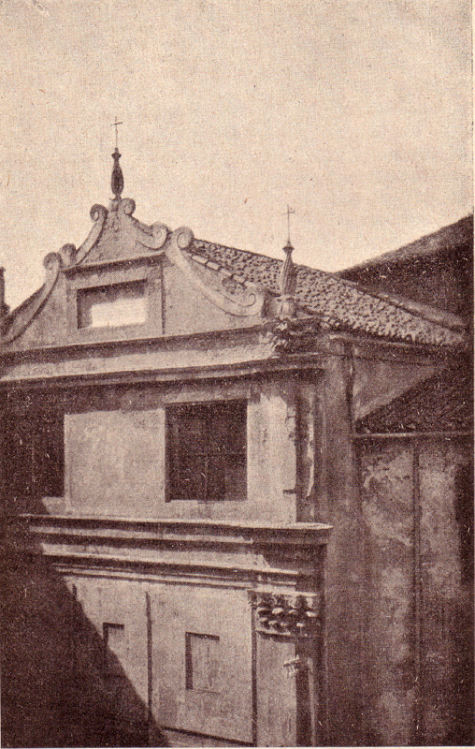

**Vicenza, chiesa di San Giacomo**

**1667**

|  |  |  |  |
| --- | --- | --- | --- |
| P. Marchi Marcantonio | Preposito | 10.5.1667 |  |

**1668**

|  |  |  |  |
| --- | --- | --- | --- |
| P. Gavellis | Preposito | 15.1.1668 |  |

**1669**

|  |  |  |  |
| --- | --- | --- | --- |
| P. Rosa Pietro Paolo | Maestro, Predicat. | Febbr. 1669 |  |

**1670**

|  |  |  |  |
| --- | --- | --- | --- |
| P. Segala M. Giuseppe | Preposito | 23.11.1670 |  |
| Fr. Tressino Alessandro | Professione | 23.11.1670 |  |

**1671**

|  |  |  |  |
| --- | --- | --- | --- |
| Ch. Avoldi Francesco | Professione | 7.4.1671 |  |
| P. Segala M. Giuseppe | Preposito | 7.4.1671  26.4.1671  2.5.1671 |  |
| Ch. Toso Matteo | Vestizione | 7.4.1671 |  |
|  |  |  |  |
| *** |  |  |  |
| P. Cosmi | Provinciale | 2.5.1671 |  |
| P. Galliani Girolamo | Generale | 7.4.1671 |  |

**1672**

**1673**

**1673**

**1674**

**1675**

**1676**

**1677**

**1678**

**1679**

|  |  |  |  |
| --- | --- | --- | --- |
| P. Marchi Marcantonio | Preposito | 2.2.1679 |  |
| *** |  |  |  |
| P. Cosmi Stefano |  | 2.2.1679 |  |
|  |  |  |  |

**1680**

**1681**

**1682**

**1683**

**1684**

**1685**

**1686**

|  |  |  |  |
| --- | --- | --- | --- |
| *P. Thiene Camillo*  *Atti Misericordia VI* | *Preposito* | *4.8.1686* |  |

**1687**

**1688**

**1689**

**1690**

**1691**

**1692**

|  |  |  |  |
| --- | --- | --- | --- |
| P. Bembo G. Francesco | Preposito | 15.4.1692 |  |

**1693**

**1694**

|  |  |  |  |
| --- | --- | --- | --- |
| *** |  |  |  |
| Mons. Bembo |  | Marzo 1694 |  |
| P. Cristoforo Pier Paolo | Vicerettore a TN | Dic. 1694 |  |

**1695**

|  |  |  |  |
| --- | --- | --- | --- |
| *** |  |  |  |
| P. Cristoforo Pier Paolo | Vicerettore a TN | Genn. 1665 |  |

**1696**

|  |  |  |  |
| --- | --- | --- | --- |
| P. Gottardi Pietro Paolo | Predicatore | Aprile 1696 |  |
| P. Rosa |  | 27.5.1696 |  |
| *** |  |  |  |
| P. Sormani | Generale - quadro | Apr. 1696 |  |

**1697**

|  |  |  |  |  |
| --- | --- | --- | --- | --- |
| P. Porto Antonio | Preposito | 26.5.1697 |  | |
| *** |  |  | |  |
| *P. Sarvetti Ferd. Carlo*  *Atti Miserixordia VI* | *Predicatore* | *Febbr. 1697* | |  |

**1698**

**1699**

**1700**