**A cura di Padre Secondo Brunelli crs**

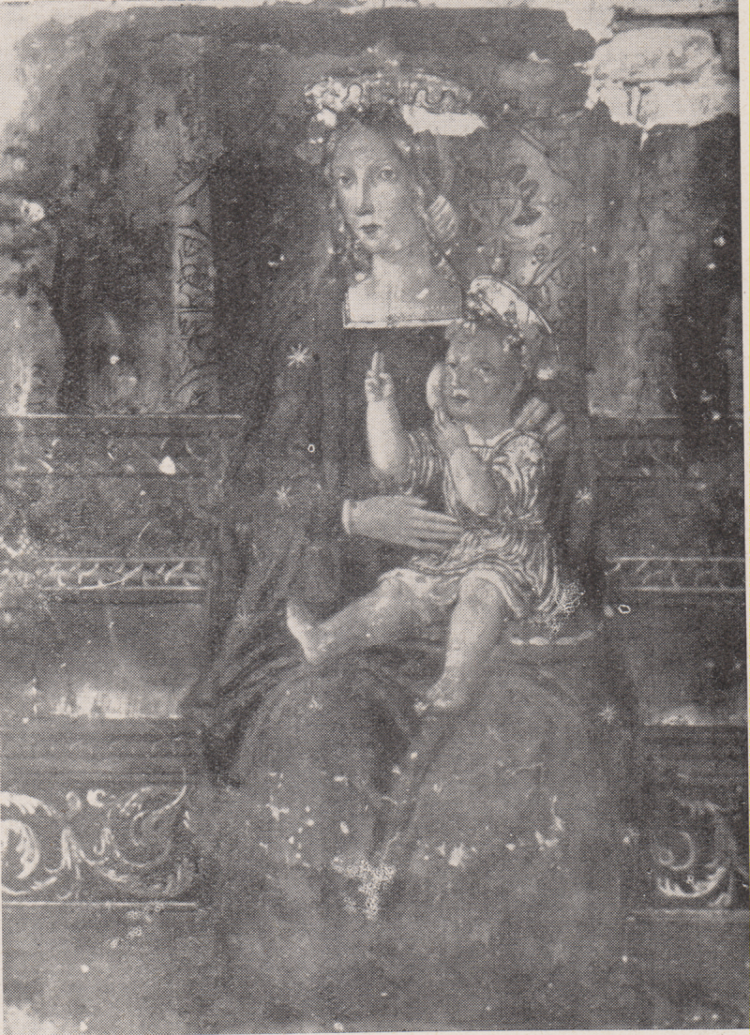

**Macerata, Madonna dei Bambini,**

**Affresco nell’abside della chiesa di S. Giovanni, Orfanotrofio, ora distrutto**

**MACERATA RELIGIOSI**

**1727-1868**

**Mestre 29.4.2017**

**1727**

|  |  |  |  |
| --- | --- | --- | --- |
| *Fr. Gnoti Giuseppe*  *Atti Salute* | *In Macerata 80 a.* | *20.1.1727* | *+ 20.1.1727* |

**1728**

|  |  |  |  |
| --- | --- | --- | --- |
| *Fr. Crosciati G.Battista*  *Atti Salute* | *In Macerata* | *5.12.1728* | *+ 5.12.1728* |

**1729**

**1730**

|  |  |  |  |
| --- | --- | --- | --- |
| *Fr. Bortoletti Giacomo*  *Atti SM Aquiro RM* |  | *30.10.1830* | *Da SM Aquiro RM* |

**1731**

|  |  |  |  |
| --- | --- | --- | --- |
| *P. Carpi Emiliano*  *Atti S. Nicolò FE* |  | *8.4.1731* | *A S. Nicolò FE* |
| *Fr. Gianelli*  *Atti Salute* | *In Macerata* | *4.1.1731* | *+ 4.1.1731* |

**1732**

|  |  |  |  |
| --- | --- | --- | --- |
| *Fr. Decarolis Tommaso*  *Atti SM Aquiro RM* | *Cuoco* | *5.12.1832* | *Da SM Aquiro RM* |

**1744**

|  |  |  |  |
| --- | --- | --- | --- |
| *P. Mantica Giacinto*  *Atti S. Maiolo PV* | *In. Macerata* | *6.4.1744* | *+ 30.3.1744* |

**1745**

|  |  |  |  |
| --- | --- | --- | --- |
| *Fr. Micheli Giacomo Giov.*  *Atti Amelia* |  | *16.4.1745*  *2.8.1745* | *Ad Amelia*  *Da Amelia* |

**1748**

|  |  |  |  |
| --- | --- | --- | --- |
| *P. Gastaldi Carlo*  *Atti Velletri* |  | *15.6.1748* | *Da Velletri* |
| *P. Ravaschieri Francesco*  *Atti Velletri* |  | *18.6.1748* | *Da Velletri* |

**1749**

|  |  |  |  |
| --- | --- | --- | --- |
| *P. Consalvi Lodovico*  *Atti Amelia* |  | *8.7.1749* | *Da Amelia* |
|  |  |  |  |
| *P. Melella Nic. Alfonso*  *Atti Velletri* |  | *25.5.1744* | *Da Velletri* |

**1750**

|  |  |  |  |
| --- | --- | --- | --- |
| *Fr. Eusebi Tommaso*  *Atti S. Maiolo PV* | *In Macerata*  *87 anni* | *17.2.1750* | ***+ 28.1.1750*** |

**1751**

|  |  |  |  |
| --- | --- | --- | --- |
| *P. Giustiniani Lorenzo*  *Atti Amelia* | *Preposito* | *1.6.1751* | *Da Amelia* |

**1752**

**1753**

|  |  |  |  |
| --- | --- | --- | --- |
| *Fr. Micheli Giovanni*  *Atti Amelia* |  | *17.6.1753* | *Ad Amelia* |

**1754**

**1755**

**1756**

**1757**

|  |  |  |  |
| --- | --- | --- | --- |
| *P. Consalvi Lodovico*  *Atti Amelia* |  | *18.9.1757* | *Da Amelia* |

**1758**

**1759**

**1760**

|  |  |  |  |
| --- | --- | --- | --- |
| *Fr. Griacchetti Nicola*  *Atti Salute VE* | *In Macerata* | *14.8.1760* | *+ 14.8.1760* |
| *Fr Chriacchetti Nicola*  *Atti Vercelli* | *In Macerata,*  *63 anni* | *4.8.1760* | *+ 4.8.1760* |
| *Fr. Quacchetti Nicola*  *Atti S. Maiolo PV* | *In Macer., 63 anni* | *31.12.1760* | *+ 1760* |

**1761**

**1762**

**1763**

**1764**

|  |  |  |  |
| --- | --- | --- | --- |
| *Fr. Pozzo Francesco*  *Atti Amelia* |  | *11.6.1764* | *Da Amelia* |

**1768**

|  |  |  |  |
| --- | --- | --- | --- |
| *P. Paganucci Francesco*  *Atti Vercelli* | *In Macerata,*  *49 anni* | *21.3.1768* | ***+ 16.3.1768*** |

1784

|  |  |  |  |
| --- | --- | --- | --- |
| *P. Pungelli Cataldo*  *Atti S. Maiolo PV* | *In Macerata* | *9.4.1784* | *+ 9.4.1784 circa* |

**1827**

|  |  |  |  |
| --- | --- | --- | --- |
| *Fr. Severini Pasquale*  *Atti SM Aquiro RM* |  | *18.11.1827* | *Da SM Aquiro RM* |

**1833**

|  |  |  |  |
| --- | --- | --- | --- |
| *Ch. Bottassi Luigi*  *Atti SM Aquiro RM* | *A Macerata* | *13.2.1833* |  |
| *P. Morroni Giuseppe*  *Atti SM Aquiro RM* |  | *21.7.1834* | *Da SM Aquiro RM* |

**1835**

|  |  |  |  |
| --- | --- | --- | --- |
| *Fr. De Carolis Tommaso*  *Atti Velletri* |  | *2.9.1835* | *A Velletri* |

**1838**

|  |  |  |  |
| --- | --- | --- | --- |
| *P. Massabò Leonardo*  *Atti SM Aquiro RM* |  | *2.11.1838* | *Da SM Aquiro RM* |

**1840**

|  |  |  |  |
| --- | --- | --- | --- |
| *Fr. Santurro Francesco*  *Atti Clementino RM* |  | *5.11.1840* | *Da Clementino RM* |

**1841**

**1842**

**1843**

|  |  |  |  |
| --- | --- | --- | --- |
| *P. Camenisch Giuseppe*  *Atti velletri* |  | *21.8.1843* | *Da Velletri* |

**1844**

|  |  |  |  |
| --- | --- | --- | --- |
| *P. Camenisch Giuseppe*  *Atti SM Aquiro RM, Velletri* | *Macerata, A Velletri* | *14.12.1844*  *24.12.1844* | *A Velletri* |
| *P. Palmieri Mariano*  *Atti SM Aquiro RM* |  | *14.12.1844* | *Da SM Aquiro RM* |

**1847**

|  |  |  |  |  |  |  |  |
| --- | --- | --- | --- | --- | --- | --- | --- |
| *Fr. Cannucci Pierfranc.*  *Atti Arona* | | |  | *14.12.1847* | | *Da Arona* | |
| *P. Palmieri Mariano*  *Atti S. Alessio RM* |  | | *22.2.1847* | *A S. Alessio RM* | |

**1848**

|  |  |  |  |
| --- | --- | --- | --- |
| *P. Ciolina Enrico Luigi*  *Atti S. Alessio RM* |  | *30.9.1848*  *16.10.1848* | *Da S. Alessio RM*  *A S. Alessio RM* |

**1849**

|  |  |  |  |
| --- | --- | --- | --- |
| *P. Guardinucci*  *Atti Clementino* |  | *8.11.1849* | *Da Clementino RM* |

**1853**

|  |  |  |  |
| --- | --- | --- | --- |
| *Fr. Del Moro Pietro*  *Atti S. Alessio RM* |  | *13.1.1853* | *A S. Alessio RM* |

**1854**

**1855**

|  |  |  |  |
| --- | --- | --- | --- |
| *P. Palmieri Mariano*  *Atti Clementino RM* | *Rett. a Macerata* | *11.1.1855* |  |

**1856**

|  |  |  |  |
| --- | --- | --- | --- |
| *Fr. Severini Pasquale*  *Atti Arona* | *In Macerata,*  *66 anni* | *11.2.1856* | *+ 11.2.1856 circa* |
| *Fr. Severini Pasquale*  *Atti Vercelli* | *In Macerata* | *16.2.1856* | *.3.2.1856* |

**1857**

|  |  |  |  |
| --- | --- | --- | --- |
| *Fr. Baraboglia Pacifico*  *Atti SM Aquiro RM* | *Oblato* | *Gen. 1857* | *Da SM Aquiro RM* |

**1858**

|  |  |  |  |
| --- | --- | --- | --- |
| *P. Palmieri Mariano*  *Atti Arona* | *In Macerata* | *5.8.1858* | *+ 5.8.1858 circa* |
| *P. Palmieri Mariano*  *Atti Vercelli* | *In Macerata* | *2.8.1858* | *+ 19.6.1858* |
| *Fr. Pima Tommaso*  *Atti S. Alessio RM* |  | *26.11.1858* | *Da S. Alessio RM* |
| *P. Rulli Gaetano*  *Atti Sl Alessio RM* |  | *21.6.1858*  *16.10.1858* | *Da S. Alessio RM*  *A S. Alessio RM* |
| *P. Sandrini Alfonso*  *Atti Clementino RM* |  | *4.10.1858* | *Da Clementino RM* |
| *P. Valmiani (?) Romano*  *Atti S. Alessio RM* | *In Macerata* | *19.6.1858* | *+ 19.6.1858* |

**1859**

|  |  |  |  |
| --- | --- | --- | --- |
| *Fr. Cima Tommaso*  *Atti S. Alessio RM* |  | *21.6.1859* | *A S. Alessio RM* |
| *Fr. Corsi Biagio*  *Atti S. Alessio RM* | *Post.* | *16.8.1859* | *A S. Alessio RM* |

**1860**

|  |  |  |  |
| --- | --- | --- | --- |
| *P. Muti Carlo*  *Atti Clementino RM* |  | *8.11.1860*  *7.12.1860* | *Da Clementino RM*  *Da S. Alessio RM* |

**1861**

|  |  |  |  |
| --- | --- | --- | --- |
| *P. Muti Carlo* | *Presente* |  |  |

**1862**

|  |  |  |  |
| --- | --- | --- | --- |
| *P. Muti Carlo*  *Atti Clementino RM* |  | *5.11.1862* | *Al Clementino RM* |

**1863**

|  |  |  |  |
| --- | --- | --- | --- |
| *P. Caucini Francesco*  *Atti Manin VE* |  | *18.10.1863*  *31.01.863* | *Dal Manin VE* |

**1864**

**1865**

**1866**

**1867**

**1868**

|  |  |  |  |
| --- | --- | --- | --- |
| *Fr. Cannuccia*  *Atti S. Alessio RM* |  | *21.12.1868* | *Da S. Alessio RM* |