**A cura di Padre Secondo Brunelli crs**

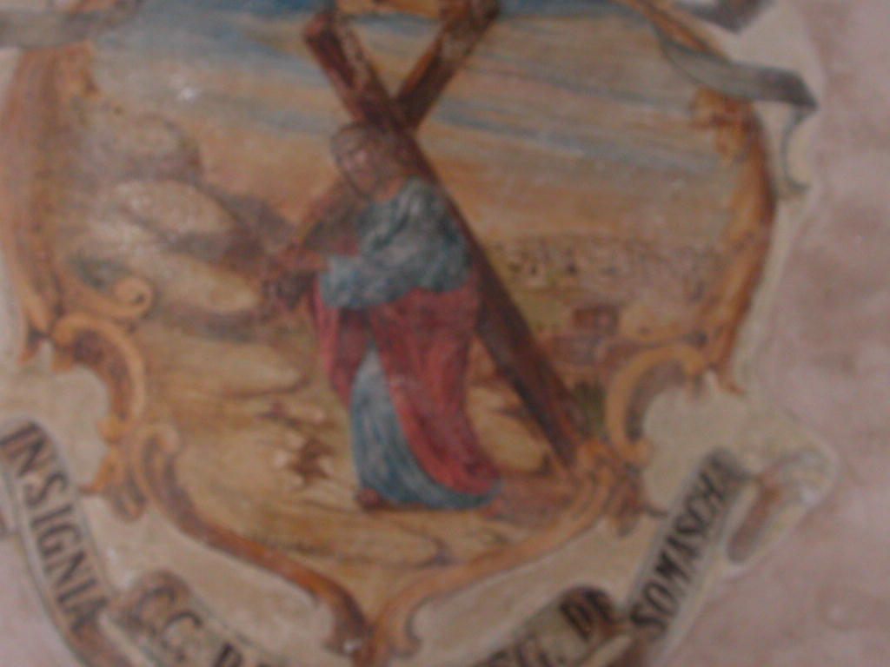

**Padova, Chiesa di Santa Croce, Gesù portacroce**

**RELIGIOSI SOMASCHI**

**SANTA CROCE - PADOVA**

**1606-1700**

**Mestre 29.4.2017**

**1606**

|  |  |  |  |
| --- | --- | --- | --- |
| P. Bramicelli Guglielmo | Generale  Preposito | 21.4.1606 |  |
| P. Lopez Gabriele |  | 1606 |  |
| P. Sartorio Giuseppe |  | 1606 |  |
| P. Stella |  | 1606 |  |

**1607**

|  |  |  |  |
| --- | --- | --- | --- |
| P. Bramicelli | Preposito  Vicario Generale | 1607 |  |
| P. Campioni G. Battista | Lettore dei casi | 1607 |  |
| P. Quadri Paolo | Curato | 1.3.1607  11.10.1607 |  |

**1608**

|  |  |  |  |
| --- | --- | --- | --- |
| P. Bramicelli | Preposito  Vicario Generale | 1608 |  |
| P. Campione G. Battista |  | 18.9.1608 |  |
| P. Campioni Sigismondo | Curato | 1608 |  |
| P. Cremaschi Andrea |  | 18.9.1608 |  |
| P. Vignati G. Battista |  | 1608 |  |
| 2 Fratelli Laici |  | 1608 |  |

**1609**

|  |  |  |  |
| --- | --- | --- | --- |
| P. Bramicelli | Preposito | 1609 |  |
| P. Cremaschi Andrea |  | 1609 |  |
| P. Tonesi G.Antonio |  | 1609 |  |
| 3 Fratelli Laici |  | 1609 |  |

**1610**

**1611**

**1612**

**1613**

**1614**

|  |  |  |  |
| --- | --- | --- | --- |
| P. Sartorio Giuseppe | Preposito | 1614 | Alla SS. Trinità VE |

**1615**

|  |  |  |  |
| --- | --- | --- | --- |
| P. Precordi Camillo | Stampa, 1615, PD | 1615 |  |

**1616**

|  |  |  |  |
| --- | --- | --- | --- |
| P. De Tognis Antonio | Curato | 19.5.1616 |  |

**1617**

|  |  |  |  |
| --- | --- | --- | --- |
| P. De Tognis Antonio | Curato | 1617 |  |

**1618**

|  |  |  |  |
| --- | --- | --- | --- |
| P. De Tognis Antonio | Curato | 20.5.1618 |  |

**1619**

**1620**

**1621**

**1622**

|  |  |  |  |
| --- | --- | --- | --- |
| P. Braga Francesco | Vicepreposito | 1622 |  |
| P. Conna G. Battista |  | 1622 |  |
| P. Mallone Tommaso | Preposito | 1622 |  |
| P. Gamberana Angiolmarco |  | 1622 |  |
| P. Mallone Tommaso | Preposito | 1622 |  |
| P. onti G. Battista | Curato | 1622 |  |
| 4 Fratelli Laici |  | 1622 |  |

**1623**

|  |  |  |  |
| --- | --- | --- | --- |
| P. Conna G. Battista |  | 1623 |  |
| P. Mallone Tommaso | Preposito | 1623 |  |
| P. Ninguarda Francesco | Vicepreposito | 1623 |  |
| P. Pulusella Pietro |  | 29.8.1623 |  |
| P. Verta G. Battista | Curato | 1623 |  |
| 5 Fratelli Laici |  | 1623 |  |

**1624**

|  |  |  |  |
| --- | --- | --- | --- |
| P. Braga Francesco | Viceproposito | 1624 |  |
| P. Conna G. Battista |  | 1624 |  |
| P. Mallone Tommaso | Preposito | 1624 |  |
| P. Moia Pierfrancesco | Maestro | 1624 |  |
| Ch. Vallotti Carlo |  | 1624 |  |
| P. Verta G. Battista | Curato | 1624 |  |
| 6 Fratelli Laici |  | 1624 |  |

**1625**

**1626**

|  |  |  |  |
| --- | --- | --- | --- |
| P. Bonfadio Pietro Defend. |  | 10.5.1828 |  |
| P. Moroni Bernardo |  | 11.10.1626 |  |
|  |  |  |  |
| P. Riva Pompeo |  | 21.7.1626 |  |

**1627**

|  |  |  |  |
| --- | --- | --- | --- |
| P. Canobio Giorgio | Viceprepos. Maestro | 1627 |  |
| P. ontica Evangelista | Preposito | 1627 |  |
| P. Canobio Giorgio | Viceprepos. Maestro | 1627 |  |
| P. ontica Francesco |  | 1627 |  |
| Ch. Leopardi Roberto |  | 1627 |  |
| Ch. Maggio Giuseppe |  | 1627 |  |
| P. Meroni Bernardo | Curato | 21.9.1727 |  |
| 4 Fratelli Laici |  | 1627 |  |

**1628**

**1629**

**1630**

|  |  |  |  |
| --- | --- | --- | --- |
| P. Cursonio Evangelista | Preposito |  | + ? |

**1631**

|  |  |  |  |
| --- | --- | --- | --- |
| P. Cursonio Evangelista |  | 12.6.1631 | **+ 12.3.1631** |

**1632**

**1633**

|  |  |  |  |
| --- | --- | --- | --- |
| P. Modena Felice |  | Gennaio 1733 |  |

**1634**

|  |  |  |  |
| --- | --- | --- | --- |
| P. Priuli G. Francesco | Curato | 7.8.1634  16.8.1634 |  |

**1635**

|  |  |  |  |
| --- | --- | --- | --- |
| P. Priuli G. Francesco | Preposito |  |  |

**1636**

|  |  |  |  |
| --- | --- | --- | --- |
| P. Priuli G. Francesco | Preposito | 1636 |  |
| P. Savageri |  | 19.9.1736 |  |

**1637**

|  |  |  |  |
| --- | --- | --- | --- |
| P. Calta Giovanni | VE? | 26.2.1637 |  |
| P. Cariddi Andrea | Preposito | 1637  26.2.1737 |  |
| P. Carraio Paolo | VE? | 26.2.1637 |  |
| P. Cerchieri Bartolomeo | VE? | 26.2.1637 |  |
| P. Frasconi Agostino | VE ? | 26.2.1637 |  |
| P. Minola Giovanni |  | 14.8.1637 |  |
| P. Priuli G.Francesco | Preposito | 1637 |  |
| P. Tonesio G. Antonio | VE? | 26.2.1637 |  |

**1638**

|  |  |  |  |
| --- | --- | --- | --- |
| Ch. Bonisenio Francesco |  | 1639 |  |
| P. Cariddi Andrea | Preposito | 1638 |  |
| p. Condino Giovanni | Viceprop. Curato | 1639 |  |
| Ch. Ferrari Marcello |  | 1639 |  |
| P. Priuli Francesco | Preposito | 1638 |  |
| P. Riva Antonio | Maestro | 1639 |  |
| 4 Fratelli Laici |  | 1639 |  |

**1639**

|  |  |  |  |
| --- | --- | --- | --- |
| P. Cariddi Andrea | Preposito | 1639 |  |

**1640**

|  |  |  |  |
| --- | --- | --- | --- |
| P. Cariddi Andrea | Preposito | 1640 |  |

**1641**

|  |  |  |  |
| --- | --- | --- | --- |
| P. Cariddi Andrea | Preposito | 1741 |  |

**1642**

|  |  |  |  |
| --- | --- | --- | --- |
| P. Cariddi Andrea | Preposito | 1742 |  |

**1643**

|  |  |  |  |
| --- | --- | --- | --- |
| P. Cariddi Andrea | Preposito | 1643 |  |

**1644**

|  |  |  |  |
| --- | --- | --- | --- |
| P. Cariddi Andrea | Preposito | 1644 |  |

**1645**

|  |  |  |  |
| --- | --- | --- | --- |
| P. Cariddi Andrea | Preposito | 1645 |  |

**1646**

|  |  |  |  |
| --- | --- | --- | --- |
| P. Cariddi Andrea | Preposito | 1646 |  |

**1647**

|  |  |  |  |
| --- | --- | --- | --- |
| P. Cariddi Andrea | Preposito | 1647 |  |

**1648**

|  |  |  |  |
| --- | --- | --- | --- |
| P. Cariddi Andrea | Preposito | 1648 |  |

**1649**

|  |  |  |  |
| --- | --- | --- | --- |
| P. Cariddi Andrea | Preposito | 1649 |  |

**1650**

|  |  |  |  |
| --- | --- | --- | --- |
| P. Baldi G. Antonio | Rettorica | 1650 |  |
| Fr. Bellotti Stefano |  | 1650 |  |
| P. Cariddi Andrea | Preposito | 1650 |  |
| P. Contarini G.Antonio | Grammatica | 1650 |  |
| P. arbarico Lamberto | Confessore | 1650 |  |
| P. Dal Pozzo Girolamo | Filosofia | 1650 |  |
| Fr. Ferrari Daniele |  | 1650 |  |
| Fr. Fornari Francesco |  | 1650 |  |
| Diac. Lucini Antonio | Prefetto | 1650 |  |
| Fr. Milesio Francesco | Prefetto | 1650 |  |
| Francesco da Bovolenta | Servente | 1650 |  |
| P. Zambellini Andrea |  |  |  |

**1651**

|  |  |  |  |
| --- | --- | --- | --- |
| P. Cariddi Andrea | Preposito | 1651 |  |

**1652**

|  |  |  |  |
| --- | --- | --- | --- |
| P. Cariddi Andrea | Preposito | 1652 |  |

**1653**

|  |  |  |  |
| --- | --- | --- | --- |
| P. Cariddi Andrea | Preposito | 1653 |  |

**1654**

|  |  |  |  |
| --- | --- | --- | --- |
| P. Cariddi Andrea | Preposito | 1654 |  |

**1655**

|  |  |  |  |
| --- | --- | --- | --- |
| P. Cariddi Andrea | Preposito | 1655 |  |

**1656**

|  |  |  |  |
| --- | --- | --- | --- |
| P. Cariddi Andrea | Preposito | 1656 |  |

**1657**

|  |  |  |  |
| --- | --- | --- | --- |
| P. Cariddi Andrea | Preposito | 1657 |  |
| P. Amore Giacomo | Stampa, 1657, PD | 1657 |  |

**1658**

|  |  |  |  |
| --- | --- | --- | --- |
| P. Cariddi Andrea | Preposito | 1658 |  |

**1659**

|  |  |  |  |
| --- | --- | --- | --- |
| P. Cariddi Andrea | Preposito | 1659 |  |

**1660**

|  |  |  |  |
| --- | --- | --- | --- |
| P. Cariddi Andrea | Preposito | 1660 |  |

**1661**

|  |  |  |  |
| --- | --- | --- | --- |
| P. Baldi Antonino | Preposito | 1661 |  |

**1662**

|  |  |  |  |
| --- | --- | --- | --- |
| P. Baldi Antonino | Preposito | 1662 |  |

**1663**

|  |  |  |  |
| --- | --- | --- | --- |
| P. Baldi Giannantonio | Preposito | 1663 |  |

**1664**

|  |  |  |  |
| --- | --- | --- | --- |
| P. Bellini Carlo | Vicepreposito | 16.10.1664 |  |
| P. Busa Antonio |  |  |  |
| P. Contarini Giovantonio | Preposito | 16.10.1664 |  |
| *** |  |  |  |
| P. Ventilati Giuseppe | Preposito | 18.10.1664 |  |

**1665**

|  |  |  |  |
| --- | --- | --- | --- |
| P. Bellini Carlo | Curato | 8.1.1665 |  |
| P. Contarini G. Antonio | Preposito | 1665 |  |
| *** |  |  |  |
| P. Passi | Definitore | 1665 |  |
| P. Priuli |  | 1665 |  |
| P. Ronzoni | Provinciale | 1665 |  |

**1666**

|  |  |  |  |
| --- | --- | --- | --- |
| P. Contarini G. Antonio | Preposito | 1666 |  |
| P. Priuli Michelangelo | Preposito | 1666 |  |

**1667**

|  |  |  |  |
| --- | --- | --- | --- |
| P. Priuli Michelangelo | Preposito | 1667 |  |

**1667**

|  |  |  |  |
| --- | --- | --- | --- |
| P. Priuli Michelangelo | Preposito | 1667 |  |

**1668**

|  |  |  |  |
| --- | --- | --- | --- |
| P. Priuli Michelangelo | Preposito | 1668 |  |

**1669**

|  |  |  |  |
| --- | --- | --- | --- |
| P. Baldi Giannantonio | Preposito | 1669  5.7.1669 | Vescovo di Chioggia |
| P. Priuli Michelangelo | Preposito | 1669 |  |
| P. arbarico Girolamo | Preposito | 1669 |  |

**1670**

|  |  |  |  |  |
| --- | --- | --- | --- | --- |
| P. arbarico Girolamo | | Preposito | 1670 |  |
| P. Priuli | | Vicepreposito |  |  |
| *P. Suardi Girolamo*  *Atti Salute* | *Pre. In Padova* | *20.8.1769* |  | |

**1671**

|  |  |  |  |
| --- | --- | --- | --- |
| P. Bellini Carlo | Curato | 28.2.1671  21.6.1671 |  |
| P. arbarico Girolamo | Preposito | 1671 |  |
| P. Caresana Paolo | Preposito | 21.6.1671 |  |
| Fr. Fontana Francesco |  | 21.6.1671 |  |
| P. Priuli Michelangelo |  | 21.6.1671 |  |
| P. Rosa Stefano |  | 21.6.1671 |  |

**1672**

|  |  |  |  |
| --- | --- | --- | --- |
| P. Caresana Paolo | Preposito | 1672  20.12.1672 |  |
| Fr. Lando Antonio |  | 1672 |  |
| P. Priuli |  | 1672 |  |

**1673**

|  |  |  |  |
| --- | --- | --- | --- |
| P. Caresana Paolo | Preposito | 1673  21.1.1673 |  |

**1674**

|  |  |  |  |
| --- | --- | --- | --- |
| P. Caresana Paolo | Preposito | 1674 |  |
| P. Campioni Giuseppe | Preposito | 1674 |  |

**Nel 1674, il padre Andrea Gambara pubblica in Padova *La porpora due volte tinta. Panegirico nella promozione al cardinalato del Rev.mo Basadonna.***

**1675**

|  |  |  |  |
| --- | --- | --- | --- |
| P. Campioni Giuseppe | Preposito | 1675 |  |

**1676**

|  |  |  |  |
| --- | --- | --- | --- |
| P. Campioni Giuseppe | Preposito | 1676 |  |

**1677**

|  |  |  |  |
| --- | --- | --- | --- |
| P. Bellini Carlo | Curato | 7.11.1677 |  |
| P. Campioni Giuseppe | Preposito | 1677 |  |
| P. Caresana Paolo | Preposito | 1677  4..4.1677  7.11.1677  12.11.1677 |  |
| P. Priuli Michelangelo | Preposito | 1677 |  |
| *** |  |  |  |
| P. Grazio Isidoro | Difensore a VE | 7.11.1677 |  |

**1678**

|  |  |  |  |
| --- | --- | --- | --- |
| P. Priuli Michelangelo | Preposito | 1678 |  |

**1679**

|  |  |  |  |
| --- | --- | --- | --- |
| P. Priuli Michelangelo | Preposito | 1679 |  |

**1680**

|  |  |  |  |
| --- | --- | --- | --- |
| P. Polacco Andrea | Preposito | 1680 |  |
| P. Priuli Michelangelo | Preposito | 1680 | + 1680 |

**1681**

|  |  |  |  |
| --- | --- | --- | --- |
| P. Polacco Andrea  *Cfr. Atti S. Bart BS* | Preposito? | 20.6.1681  22.7.1681 |  |
| *** |  |  |  |
| P. Cosmi |  | 20.6.1681 |  |
| P. Dionisio Girolamo | Rett. S. Zeno VR | 20.6.1681  22.7.1681 |  |

**1682**

|  |  |  |  |
| --- | --- | --- | --- |
| Fr. Magri Sebastiano | Maestro Rettorica | 1682 |  |
| P. Polacco Andrea | Preposito | 1682 |  |
| *** |  |  |  |
| P. Allegri |  | 1682 |  |
| P. Bellini Cralo |  | 1682 |  |
| Fr. Fontana Francesco |  | 1682 |  |
| P. Priuli |  | 1682 |  |
| P. Rota Stefano |  | 1682 |  |

**1683**

|  |  |  |  |
| --- | --- | --- | --- |
| P. Caro Francesco | Preposito | 1683 |  |
| P. Pettirosso Francesco | Procuratore | 13.1.1683 |  |
| P. Polacco Andrea | Preposito | 1683 |  |
| P. Sonica Pietro |  | 13.1.1783 |  |

**1684**

|  |  |  |  |
| --- | --- | --- | --- |
| P. Caro Francesco | Preposito | 1684 |  |
| P. Sonica Pietro | Procuratore | 30.5.1684  9.6.1684 |  |
| *** |  |  |  |
| P. Bornato Girolamo | Rett. S. Zeno VR | 31.5.1684 |  |
| P. Caresana |  | 31.5.1684 |  |
| P. Fossadoni g. Battista | Generale | 31.5.1684 | In visita |
| P. Gambara Andrea | Stampa, 1684, PD | 1684 |  |

**1685**

|  |  |  |  |
| --- | --- | --- | --- |
| P. Caro Francesco | Preposito | 1685 |  |
| P. Gambara Andrea | Stampa, 1685, PD | 1685 |  |

**Nel 1685, il P. Andrea Gambara pubblica in Padova *Venetae Laudes.***

**1686**

**1687**

**1688**

|  |  |  |  |
| --- | --- | --- | --- |
| P. Gambara Andrea | Stampa, 1688, VE | 1688 |  |

**1689**

**1690**

|  |  |  |  |
| --- | --- | --- | --- |
| P. Capello Girolamo Vinc. | Preposito | 1690 |  |
| P. Gambara Andrea | Stampa, 1690, PD | 1690 |  |

**Nel 1690, il P. Gambara Andrea pubblica in Padova *La signoria della servitù. Panegirico di San Filippo Bnitio***

**1691**

|  |  |  |  |
| --- | --- | --- | --- |
| P. Ginali Francesco | Preposito | 8.9.1691 |  |
| P. Sonica Pietro | Curato | 8.9.1691 |  |

**1692**

**1693**

|  |  |  |  |
| --- | --- | --- | --- |
| P. Sonica Pietro | Preposito | 1693 |  |

**1694**

|  |  |  |  |
| --- | --- | --- | --- |
| P. Bonetti Leonardo | Stampa 1694, PD | 1694 |  |
| P. Sonica Pietro | Preposito | 1694 |  |

**Nel 1694. Filippo Nani pubblica in Padova *Applausi al merito sublime dell’Ill.mo Filippo Nani, Prencipe dell’Accademia de’ ben guidati, nel Collegio dei PP. Somaschi in Padova.***

**1695**

|  |  |  |  |
| --- | --- | --- | --- |
| P. Ferretti Pietro | Preposito | 1695 |  |
| P. Sonica Pietro | Preposito? | 1695 |  |

**1696**

|  |  |  |  |
| --- | --- | --- | --- |
| P. Polacco Andrea | Preposito | 1696 |  |
| P. Sonica Pietro | Preposito ? | 1696 |  |

**1697**

|  |  |  |  |
| --- | --- | --- | --- |
| P. Polacco Andrea | Preposito | 1697 |  |
| P. Ferretti Pietro | Preposito | 1697 |  |

**1698**

|  |  |  |  |
| --- | --- | --- | --- |
| P. Polacco Andrea | Preposito | 1698 |  |

**1699**

|  |  |  |  |
| --- | --- | --- | --- |
| P. Polacco Andrea | Preposito | 1699 |  |

**1700**

|  |  |  |  |
| --- | --- | --- | --- |
| P. Polacco Andrea | Preposito | 1700 |  |
| *** |  |  |  |
| P. Caro Francesco |  | 6.9.1700 |  |
| P. Frugoni Carlo Girolamo |  | 6.9.1700 |  |
| P. Graziani Paolo Andrea | Provinciale | 6.9.1700 |  |