**A cura di Padre Secondo Brunelli crs**

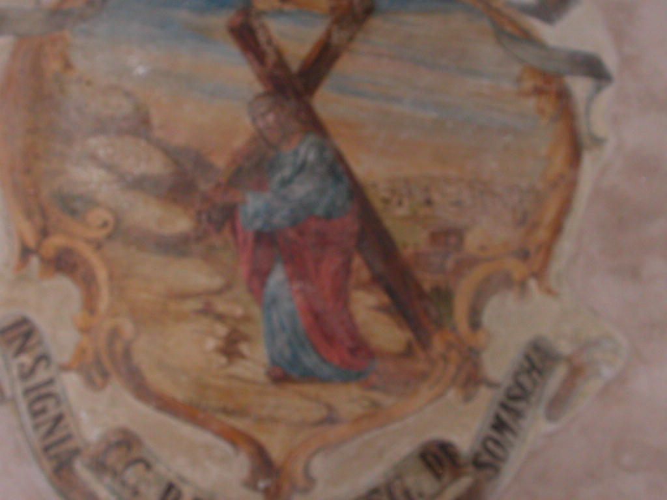

Padova, Chiesa di Santa Croce, Gesù portacroce

**RELIGIOSI SOMASCHI**

**SANTA CROCE - PADOVA**

**1701-1750**

**Mestre 29.4.2017**

**1701**

|  |  |  |  |
| --- | --- | --- | --- |
| P. Ferretti Pietro | Preposito | 1701 |  |
| P. Polacco Andrea | Preposito | 1701 |  |

**1702**

|  |  |  |  |
| --- | --- | --- | --- |
| P. Ferretti Pietro | Preposito | 1702 |  |

**1703**

|  |  |  |  |
| --- | --- | --- | --- |
| P. Ferretti Pietro | Preposito | 1703 |  |

**1704**

|  |  |  |  |
| --- | --- | --- | --- |
| P. Ferretti Pietro | Preposito | 1704 |  |
| P. lighi Agostino | Preposito | 1704 |  |

**1705**

|  |  |  |  |
| --- | --- | --- | --- |
| P. lighi | Preposito | 16.5.1705  24.9.1705 |  |
| P. Sonica Pietro | Preposito | 1705 |  |

**1706**

|  |  |  |  |
| --- | --- | --- | --- |
| P. Sonica Pietro | Preposito | 1706 |  |

**1707**

|  |  |  |  |
| --- | --- | --- | --- |
| P. Sonica Pietro | Preposito | 1707 |  |
| P. lighi Agostino | Preposito | 1707 |  |

**1708**

|  |  |  |  |
| --- | --- | --- | --- |
| P. lighi Agostino | Preposito | 1708 |  |
| P. Sonica Pietro | Preposito | 1708 |  |

**1709**

|  |  |  |  |
| --- | --- | --- | --- |
| P. Sonica Pietro | Preposito | 1709 |  |

**1710**

|  |  |  |  |
| --- | --- | --- | --- |
| P. Bertucci |  | 20.12.1710 | A S. Zeno VR |
| P. Lazzari Antonio | Maestro Filosofia | 14.6.1710 | A Venezia |
| P. Molo | Lettore Filosofia | Sett. 1710 |  |
| P. Sonica Pietro | Preposito | 1710  4.6.1710 |  |
| P. Vecelli Carlo | Preposito | 1710  4.6.1710 |  |

**1711**

|  |  |  |  |
| --- | --- | --- | --- |
| P. Antonini | Orazione Studi | 29.11.1711 |  |
| P. Vecellio Carlo | Preposito | 1711 |  |

**1712**

|  |  |  |  |
| --- | --- | --- | --- |
| P. Airoldi Cesare | Maestro Retorica  Accademia | 20.5.1712  Sett.1712 | Da Milano |
| P. Antonini |  | 1712 |  |
| P. Vecellio Carlo | Preposito | 1712 |  |

**1713**

|  |  |  |  |
| --- | --- | --- | --- |
| P. Airoldi Cesare | Orazione Studi | 20.12.1713 |  |
| P. Antonini |  | 1713 |  |
| P. Soari | Maestro | 20.11.1713 | A Castello VE |
| P. Vecellio Carlo | Preposito | 1713 |  |

**1714**

|  |  |  |  |
| --- | --- | --- | --- |
| P. Antonimi | Lettore Filosofia | Nov. 1714 |  |
| P. Pisoni Alberto | Preposito | 1714 |  |
| P. Vecellio Carlo | Preposito | 1714 |  |
| *** |  |  |  |
| P. Sonica Pietro | Lascito 1200 ducati | 1714 | (+1714) |
| P. Vecellio Giacomo | Vicario Generale | 1714 |  |

**1715**

|  |  |  |  |
| --- | --- | --- | --- |
| P. Antonimi Leopoldo | Accademia-Stampa | Nov. 1715 | A Vicenza |
| P. Pisoni Alberto | Preposito | 1715 |  |

**Nel 1715, si pubblica in Padova *Il tempio dell’eternità aperto agli Argonauti ... da Signori Convittori del Collegio di Santa Croce sotto la direzione de’ Padri della Congregazione di Somasca.***

**1716**

|  |  |  |  |
| --- | --- | --- | --- |
| P. Imperiali Leonida | Vicepeposito | 31.8.1716 |  |
| P. Pisoni Alberto | Preposito | 1716 |  |

**1717**

|  |  |  |  |
| --- | --- | --- | --- |
| P. Imperiali Leonida | Preposito ? | 10.5.1717 |  |
| P. Pisoni Alberto | Preposito | 10.5.1717 |  |
| P. Vecellio Giacomo | Preposito | 1717 |  |
| P. Vecellio Giacomo | Ass. Generale | 10.5.1717 |  |
| *** |  |  |  |
| P. Rossi Giov.Antonio | Provinciale | 10.5.1717 |  |

**1718**

|  |  |  |  |
| --- | --- | --- | --- |
| P. Vecellio Giacomo | Preposito | 1718 |  |

**1719**

|  |  |  |  |
| --- | --- | --- | --- |
| P. Bassanello |  | Agosto 1719 | A Salò BS |
| P. Vecellio Giacomo | Preposito | 1719 |  |

**1720**

|  |  |  |  |
| --- | --- | --- | --- |
| P. Ferretti Pietro | Preposito | 1720 |  |
| P. Vecellio Giacomo | Preposito | 1720 |  |

**1721**

|  |  |  |  |
| --- | --- | --- | --- |
| *Fr. Almetti Agostino*  *Atti SM.Bianca FE* |  | *22.10.1721* | *A S. M. Bianca FE* |
| P. Ferretti Pietro | Preposito | 1721 |  |

**1722**

|  |  |  |  |
| --- | --- | --- | --- |
| P. Ferretti Pietro | Preposito | 1722 |  |

**1723**

|  |  |  |  |
| --- | --- | --- | --- |
| *P. Ferretti Pietro* | Preposito | 1723 |  |
| *P. Fontana Giacomo* | Preposito | 1723 |  |

**1724**

|  |  |  |  |
| --- | --- | --- | --- |
| P. Fontana Giacomo | Preposito | 1724 |  |

**1725**

|  |  |  |  |
| --- | --- | --- | --- |
| P. Fontana Giacomo | Preposito | 1725 |  |

**1726**

|  |  |  |  |
| --- | --- | --- | --- |
| P. Fontana Giacomo | Preposito | 1726 |  |
| P. Pacata | Preposito | 1726 |  |
| P. Pisenti G. Bernardo |  | 1726 | Da S. Maiolo PV |

**1727**

|  |  |  |  |
| --- | --- | --- | --- |
| P. Pacata | Preposito | 1727 |  |
| *Fr. Rovere Antonio*  *Atti Salute VE* | | *In PD, 57 anni* | *30.4.1727* | *+ 30.4.1727* | |

**1728**

|  |  |  |  |
| --- | --- | --- | --- |
| P. Pacata | 1728 | 1728 |  |

**1729**

|  |  |  |  |
| --- | --- | --- | --- |
| P. Pacata | Preposito | 1729 |  |
| P. Pisoni Alberto | Preposito | 1729 |  |
| P. Taglioni Gianmaria |  | 6.11.1729 | Da Feltre |

**1730**

|  |  |  |  |
| --- | --- | --- | --- |
| P. Pisoni Alberto | Preposito | 1730 |  |
| *** |  |  |  |
| P. Gottardi Pietro Paolo | Provinciale | 1730 |  |

**1731**

|  |  |  |  |  |  |
| --- | --- | --- | --- | --- | --- |
| P. Pisoni Alberto | | Preposito | 1731  15.6.1733 | |  |
| Fr. Pandino Gioacchino  *Atti Feltreo* | |  | 29.5.1731  *29.5.1831* | | Da Feltre  *Da Feltre* |
| *Fr. Silvieto Pietro*  *Atti Salute VE* |  | *10.7.1731* | *Dalla Salute VE* | | |

**1732**

|  |  |  |  |  |  |  |
| --- | --- | --- | --- | --- | --- | --- |
| P. Pisoni Alberto | | Preposito | 1732 | | |  |
| *P. Santacroce Francesco*  *Atti Salute* | *In Padova* | | *10.11.1732* | *+ 10.11.1732* | | |

**1733**

|  |  |  |  |
| --- | --- | --- | --- |
| P. Leonarducci Gaspare | Preposito | 1733 |  |
| P. Pisoni Alberto | Preposito | 1.3.1733 |  |
| *P. Salomoni Gius. Alberto*  *Atti Lugano* |  | *10.5.1733* | *Da Lugano* |
| Zucchi Giammarino | Ospite | 1.3.1733 |  |

**1734**

|  |  |  |  |
| --- | --- | --- | --- |
| P. Leonarducci Gaspare | Preposito | 1734 |  |
| P. Modena Felice Maria | Curato | 28.4.1734 |  |
| P. Pisoni Alberto | Preposito | 1734 |  |

**1735**

|  |  |  |  |  |  |
| --- | --- | --- | --- | --- | --- |
| P. Leonarducci Gaspare | | Preposito | 1735 |  | |
| P. Pisenti G.Bernardo  *Atti Salute VE* | |  | 1735  *1.10.1735* | Arrivo  *Dalla Salute VE* | |
| P. Pisoni Alberto | |  | 20.7.1735 |  | |
| *P. Strazza Carlo*  *Atti Salute VE* | *In Padova* | *3.9.1735* | | *+ 3.9.735* | |

**1736**

|  |  |  |  |
| --- | --- | --- | --- |
| P. Barbarico Domenico | Preposito | 1736 |  |
| P. Leonarducci Gaspare | Preposito | 1736 |  |
| P. Pisenti G.Bernardo |  | 1736 |  |
| P. Savageri |  | 19.9.1736 |  |

**1737**

|  |  |  |  |
| --- | --- | --- | --- |
| P. Aldighieri Domenico | Preposito | 1737 |  |
| P. Minoia Giovanni |  | 14.8.1637 |  |
| P. Pisenti B. Bernardo |  | 1737 |  |
| P. Scalabrini tommaso | Procuratore | 7.12.1737 |  |

**1738**

|  |  |  |  |
| --- | --- | --- | --- |
| P. Aldighieri Domenico | Preposito | 1738 |  |
| P. Pisenti G. Bernardo |  | 1738 |  |

**1739**

|  |  |  |  |
| --- | --- | --- | --- |
| P. Aldighieri Domenico | Preposito | 1739 |  |
| P. Pisoni Alberto | Preposito | 1739 |  |
| P. Pisenti G. Bernardo |  | 1739 (?) | A Salute VE |

**Nel 1739, si pubblica in Padova *Oratio habita in gymnasio patavino a Jacopo Stellini Stellini C.R.S. Cum Ethicen tradere ingrederetur.***

**1740**

|  |  |  |  |
| --- | --- | --- | --- |
| P. Pisoni Alberto | Preposito | 1740 |  |
| *** |  |  |  |
| P. Pisenti G. Bernardo | (Da Venezia) | 29.10.1740 |  |

**1741**

|  |  |  |  |
| --- | --- | --- | --- |
| P. Leonarducci Gaspare | Curato | 1741 |  |
| P. Pisoni Alberto | Preposito | 1741 |  |
| P. Scalabrini Tommaso | Curato | 1741 |  |
| *** |  |  |  |
| P. Pisenti G. Bernardo |  | Autunno 1741 |  |

**1742**

|  |  |  |  |
| --- | --- | --- | --- |
| *P. Barca G.Battista*  *Atti Salute VE* |  | *12.11.1742* | *Alla Salute VE* |
| P. Fasci Bartolomeo |  | Giugno 1742 |  |
| P. Pisoni Alberto | Preposito | 1742 |  |
| P. Scalabrini Tommaso | Curato | 7.9.1742 |  |
| Zucco Gianmaria | Ospite, 88 anni | 23.6.1742 | **+ 23.6.1742** |

**1743**

|  |  |  |  |
| --- | --- | --- | --- |
| P. Pisoni Alberto | Preposito | 1742 |  |
| P. Scalbrini Tommaso | Curato | 1743 |  |

**1744**

|  |  |  |  |
| --- | --- | --- | --- |
| P. Pisoni Alberto | Preposito | 1744 |  |
| P. Scalabrini Tommaso | Curato | 7.1.1744 |  |
| P. Toninelli Crescenzio | Anni 39 |  |  |

**1745**

|  |  |  |  |
| --- | --- | --- | --- |
| D. Accatini Tommaso | Secolare, anni 30 | 21.1.1745 | Prefetto |
| Ch. Amai Federico | Secolare | 21.1.1745 |  |
| Ch. Contin D. B. | Secolare, anni 28 | 21.1.1745 |  |
| D. De Sanctis Francesco | Secolare, anni 60 | 21.1.1745 | Prefetto |
| P. Leonarducci Gaspare | Preposito | 1745 |  |
| P. Pisoni Alberto | Preposito | 1745 |  |
| D. Pucci Pietro | Secolare,anni 40 | 21.1.1745 | Prefetto |
| P. Scalabrini Tommaso | Curato | 21.1.1745 |  |
| P. Toninelli Crescenzio | Anni 39 | 21.1.1745 |  |
| *** |  |  |  |
| P. Riulfi Carlo Giuseppe | Cancell. Generale | 1745 |  |

**1746**

|  |  |  |  |
| --- | --- | --- | --- |
|  | Preposito | 1746 |  |

**1747**

|  |  |  |  |
| --- | --- | --- | --- |
| P. Leonarducci Gaspare | Preposito | 1747 |  |

**1748**

|  |  |  |  |
| --- | --- | --- | --- |
| P. Leonarducci Gaspare | Preposito | 1748 |  |
| P. Pisoni Alberto | Preposito | 1748 |  |

**1749**

|  |  |  |  |
| --- | --- | --- | --- |
| *P. Aldighieri Domenico*  *Atti S. Maiolo PV* | *In Padova*  *77 anni* | *5.12.1749* | ***+ 24.11.1749*** |
| P. Allegri Domenico | Anni 80 | 24.11.1749 | **+ 24.11.1749** |
| P. Pisoni Alberto | Preposito | 1749 |  |
| *** |  |  |  |
| P. Baldini G. Francesco | Generale | 7.4.1749 | In visita |

**1750**

|  |  |  |  |
| --- | --- | --- | --- |
| P. Pisoni Alberto | Preposito | 1750 |  |