**A cura di Padre Secondo Brunelli crs**

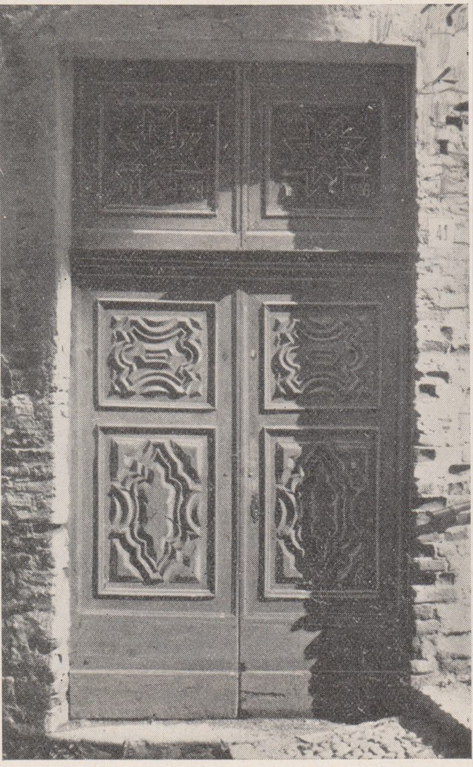

Biella, portale della chiesa chiesa di S. Lorenzo del Collegio dei Padri Somaschi,

**RELIGIOSI SOMASCHI**

**BIELLA**

**Cfr. Riv. Congr., fasc. 5, 1925, A(ngelo) S(toppiglia), *Il Collegio S. lorenzo in Biella. I Somaschi al Santuario di Oropa. Note storiche, pag. 172-175***

**Mestre 29.4.2017**

**I Somaschi, a cura di Migliorini, 1992, pag. 245-24 7 sottolineato )**

**1650**

|  |  |  |  |
| --- | --- | --- | --- |
| Fr. Macotto Bartolomeo |  | 6.3.1650 |  |
| P. Monticelli G. Battista | Preposito | 6.3.1650 |  |
| P. Necchi Stefano | Viceprep.to | 6.3.1650 |  |
| P. Forlani Carlo |  | 6.3.1650 |  |

**1706**

|  |  |  |  |
| --- | --- | --- | --- |
| *P. Riva Carlo*  *Atti Lugano* |  | *4.2.1706* | *Da Lugano* |

**1707**

|  |  |  |  |
| --- | --- | --- | --- |
| *P. Riva Carlo* |  | *Presente* |  |

**1708**

|  |  |  |  |
| --- | --- | --- | --- |
| *P. Riva Carlo* |  | *Presente* | *Ad Alessandria* |

**1710**

|  |  |  |  |
| --- | --- | --- | --- |
| *P. Riva Carl’Antonio*  *Atti Lugano* |  | *12.11.1710* | *Da Lugano* |

**1711**

|  |  |  |  |  |  |  |
| --- | --- | --- | --- | --- | --- | --- |
| *P. Bassi Giuseppe*  *Atti Merate* | |  | | *5.11.1711* | *Da Merate* | |
| *P. Riva Carl’Antonio* |  | | *Presente* | | |  |

**1712**

|  |  |  |  |
| --- | --- | --- | --- |
| *P. Riva Carl’Antonio* |  | *Presente* |  |

**1713**

|  |  |  |  |
| --- | --- | --- | --- |
| *P. Riva Carl’Antonio* |  | *Presente* |  |

**1714**

|  |  |  |  |
| --- | --- | --- | --- |
| *P. Riva Carl’Antonio* |  | *1.11.1714* | *A Lugano* |

**1715**

**1716**

**1717**

**1718**

**1719**

|  |  |  |  |
| --- | --- | --- | --- |
| *P. Pontelio Carlo Giac.*  *Atti Clementino RM* |  | *6.11.1719* | *Da Clementino RM* |

**1720**

|  |  |  |  |
| --- | --- | --- | --- |
| *P. Pontelio Carlo Giac.* | *Rettorica* | *Presente* |  |

**1721**

|  |  |  |  |
| --- | --- | --- | --- |
| *P. Pontelio Carlo Giac.* | *Rettorica* | *Presente* |  |

**1722**

|  |  |  |  |
| --- | --- | --- | --- |
| *P. Pontelio Carlo Giac.* | *Rettorica* | *Presente* |  |

**1723**

|  |  |  |  |
| --- | --- | --- | --- |
| *P. Pontelio Carlo Giac.* | *Rettorica* | *Presente* |  |

**1724**

|  |  |  |  |
| --- | --- | --- | --- |
| *P. Pontelio Carlo Giac.* | *Rettorica* | *Presente* |  |

**1725**

|  |  |  |  |
| --- | --- | --- | --- |
| *P. Pontelio Carlo Giac.* | *Rettorica* | *Presente* |  |

**1726**

|  |  |  |  |
| --- | --- | --- | --- |
| *P. Pontelio Carlo Giac.* | *Rettorica* | *Presente* |  |

**1727**

|  |  |  |  |
| --- | --- | --- | --- |
| *P. Mariani Pietro Maria*  *Atti Lugano* |  | *20.9.1727* | *A Biella* |
| *P. Pontelio Carlo Giac.* | *Rettorica* | *Presente* |  |
| *P. Salomone Gius.Alberto*  *Atti Lugano* |  | *9.11.1727* | *A Lugano* |

**1728**

|  |  |  |  |
| --- | --- | --- | --- |
| *P. Pontelio Carlo Giac.* | *Rettorica* | *Presente* |  |

**1729**

|  |  |  |  |
| --- | --- | --- | --- |
| *P. Pontelio Carlo Giac.* | *Rettorica* | *Presente* |  |

**1730**

|  |  |  |  |
| --- | --- | --- | --- |
| *P. Pontelio Carlo Giac.* | *Rettorica* | *Presente* |  |

**1731**

|  |  |  |  |
| --- | --- | --- | --- |
| *P. Pontelio Carlo Giac.* | *Rettorica* | *Presente* |  |

**1732**

|  |  |  |  |
| --- | --- | --- | --- |
| *P. Pontelio Carlo Giac.* | *Rettorica* | *Presente* |  |

**1733**

|  |  |  |  |
| --- | --- | --- | --- |
| *P. Pontelio Carlo Giac.* | *Rettorica* | *Presente* |  |

**1734**

|  |  |  |  |
| --- | --- | --- | --- |
| *P. Mainardi Francesco*  *Atti S. Maiolo PV* |  | *2.7.1734* | *A S. Maiolo PV* |
| *P. Pontelio Carlo Giac.* | *Rettorica* | *1735* | *A Casale* |

**1735**

|  |  |  |  |
| --- | --- | --- | --- |
| *P. Pontelio Carlo Giac.* | *Rettorica* | *Presente* |  |
| *Fr. PuricelliCarlo Girolamo*  *Atti Tortona* |  | *10.6.1735* | *A Tortona* |

**1742**

|  |  |  |  |
| --- | --- | --- | --- |
| *Fr. Bresciano Pietro*  *Atti S. Maiolo PV* | *A Biella* | *31.3.1742* | *+ 15.3.1742* |

**1751**

|  |  |  |  |
| --- | --- | --- | --- |
| *P. Charmet Giovanni*  *Atti Vercelli* | *Rettore* | *2.6.1751* | *Da Vercelli* |

**1754**

|  |  |  |  |
| --- | --- | --- | --- |
| *P. Chermes Giovanni*  *Atti S. Maiolo PV* |  | *27.6.1754* | *A S. Maiolo PV* |
| *Fr. Ferno Gaetano*  *Atti Vercelli* |  | *6.6.1754* | *Da Vercelli* |

**1756**

|  |  |  |  |
| --- | --- | --- | --- |
| *Fr. Onorio Clemente*  *Atti Tortona* |  | *29.4.1756* | *Da Tortona* |

**1758**

|  |  |  |  |
| --- | --- | --- | --- |
| *P. Calderara Michele M.a*  *Atti Tortona* |  | *23.6.1758* | *Da Tortona* |
| *P. Gais Giuseppe*  *Atti Tortona* |  | *28.6.1758* | *A Tortona* |

**1760**

**1761**

|  |  |  |  |
| --- | --- | --- | --- |
| *P. Calderaia Michele*  *Atti Vercelli* | *( di Biella )* | *4.5.1761* |  |

**1762**

**1763**

**1764**

|  |  |  |  |
| --- | --- | --- | --- |
| *P. Mafezzoli Giambattista*  *Atti Merate* |  | *29.8.1764* | *Da Merate* |

**1765**

**1766**

|  |  |  |  |
| --- | --- | --- | --- |
| *P. Malacrida Luigi*  *Atti SMS MI* | *Predicazione* | *3.2.1766*  *19.2.1766* | *Da SM Segreta MI* |

**1767**

**1768**

**1769**

**1770**

**1778**

|  |  |  |  |
| --- | --- | --- | --- |
| *P. Lamberti Luigi* | *Prep.to* | *1778* |  |

**1779**

|  |  |  |  |
| --- | --- | --- | --- |
| *P. Lamberti Luigi* | *Prep.to* | *1779* |  |

**1780**

|  |  |  |  |
| --- | --- | --- | --- |
| *P. Lamberti Luigi* | *Prep.to* | *1780* |  |

**1781**

|  |  |  |  |
| --- | --- | --- | --- |
| *P. Lamberti Luigi* | *Prep.to* | *1781* |  |

**1788**

|  |  |  |  |
| --- | --- | --- | --- |
| *P. Serpenti*  *Atti salute* | *In Biella* | *8.6.1788* | *+ 8.6.1788* |

**1789**

**1790**

|  |  |  |  |
| --- | --- | --- | --- |
| *Fr. Granelli Giuseppe*  *Atti Vigevano* |  | *5.1.1790* | *A Vercelli* |

**1791**

**1792**

**1793**

|  |  |  |  |
| --- | --- | --- | --- |
| *Fr. Granelli Giuseppe*  *Atti vercelli* |  | *19.12.1793* | *Da Vercelli* |